- Create Database

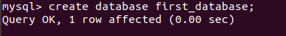

- Design Schema
- Create tables

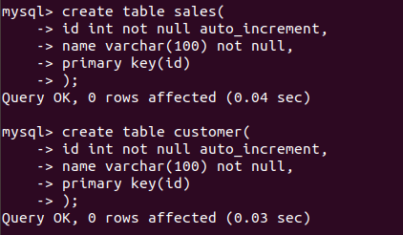

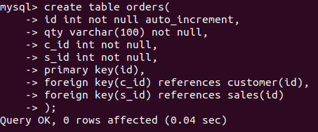

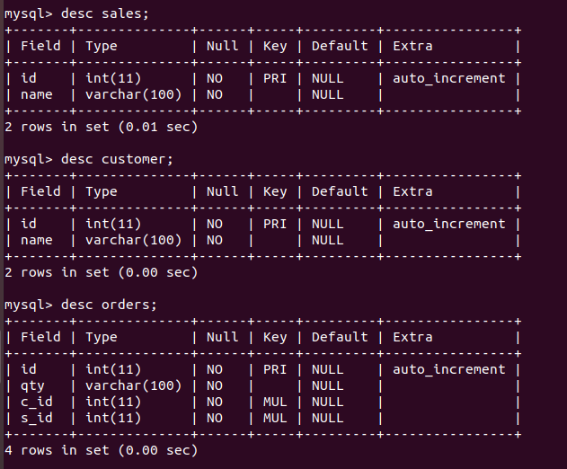

- Insert sample data

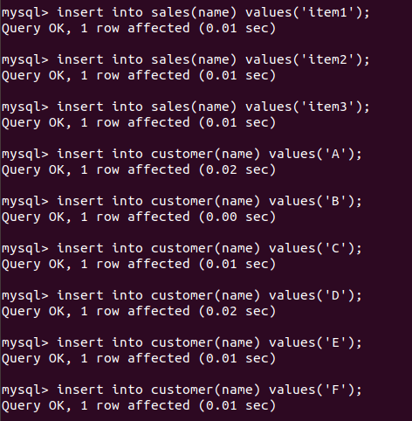

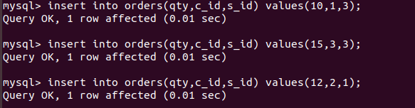

- Find the sales person have multiple orders.

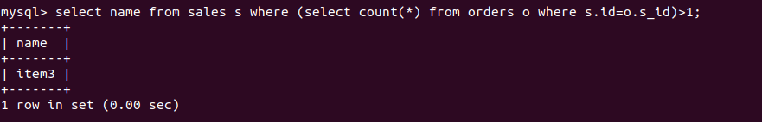

- Find the all sales person details along with order details

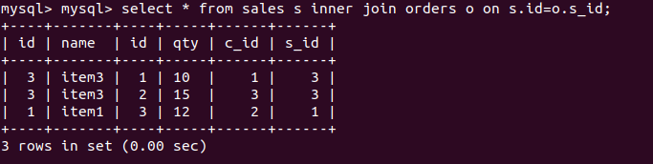

- Create index

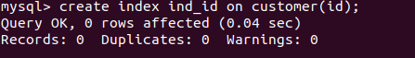

- How to show index on a table

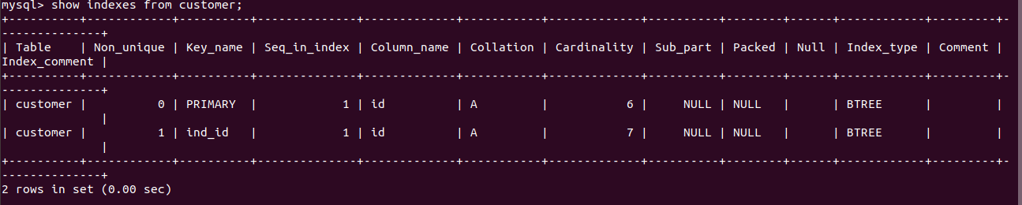

- Find the order number, sales person name, along with the customer to whom that order belongs to
